Lincoln University College
Faculty of Computer Science and Multimedia
Cafe Management System
A PROJECT REPORT
Submitted to
Department of Information Technology
Phoenix College of Management
Maitidevi, Kathmandu
In partial fulfillment of the requirements for the Bachelor in Information
Technology (BIT)
Submitted by
Amit Tharu
BIT 7th Semester
University ID : LC0003001642
2026/04/15

DECLARATION
I hereby declare that the project report entitled “Cafe Management System” is my original work, completed under the guidance of the assigned supervisor. This report has not been submitted elsewhere, in full or in part, for the award of any degree, diploma, or other academic recognition.

Signature:
Name: Amit Tharu
Date: 2026/03/22



Lincoln University College
Faculty of Computer Science and Multimedia
Phoenix College of Management
Maitidevi, Kathmandu
Bachelors in Information Technology (BIT)
LETTER OF APPROVAL
The Project report entitled “Cafe Management System” submitted by Amit Tharu, in partial fulfillment of the requirements for the Bachelor’s degree in Information Technology, has been accepted as a record of work independently carried out.
In our opinion, it is satisfactory in quality and meets the requirements for mid defense evaluation.

Er. Santosh Dhungana Mr. Bijaya Mishra
Head of Department Program Coordinator

Mr. Saishab Bhatarai External Examiner
Internal Examiner
ABSTRACT

The Cafe Management System is a web-based application designed to automate and streamline the daily operations of cafes. Traditional cafe management often relies on manual processes such as handwritten orders, manual billing, and separate inventory tracking, which leads to inefficiencies, errors, and delays.
This system provides a centralized platform for managing orders, billing, menu items, inventory, and reports. It allows staff to place orders digitally, generate bills automatically, and track inventory in real time. The admin can manage users, monitor sales performance, and generate reports for better decision-making.
The system aims to improve service speed, reduce human errors, and enhance overall operational efficiency, making it suitable for small and medium-sized cafes.

Keywords: Cafe Management, Billing System, Inventory Management, Automation, Web Application

ACKNOWLEDGMENT

I would like to express my sincere gratitude to Mr. Saishab Bhattarai for their valuable guidance and continuous support throughout this project.
I am deeply thankful to my beloved parents for their encouragement and support. I also extend my appreciation to my friends and colleagues who helped me during the development of this project.
Lastly, I would like to thank the faculty members of the IT department for providing me with the opportunity and resources to complete this project successfully.

CERTIFICATE
This is to certify that the project report entitled “Cafe Management System” submitted by Amit Tharu, University ID: LC0003001642 to Lincoln University in partial fulfillment of the requirements for the bachelor in Information Technology, is a record of original work carried out under supervision and guidance.

Supervisor Name: Saishab Bhattarai
Designation: Project Coordinator
Signature:

Contents

LIST OF FIGURES

CHAPTER 1: INTRODUCTION
1.1 Introduction ........................................................................ 1
1.2 Problem Statement ........................................................... 2
1.3 Project Objectives ............................................................ 3
1.4 Significance of the Project ............................................ 4
1.5 Limitations of the Project .............................................. 5
1.6 Development Methodology ........................................... 6
1.7 Organization of the Report ........................................... 7

CHAPTER 2: BACKGROUND STUDY AND LITERATURE REVIEW
2.1 Background of the Study ............................................... 8
2.2 Literature Review ............................................................ 10

CHAPTER 3: SYSTEM ANALYSIS
3.1 System Analysis ............................................................... 12
3.1.1 Requirement Analysis ................................................ 13
• Functional Requirements ........................................... 14
• Non-Functional Requirements ................................ 15
3.1.2 Feasibility Analysis .................................................... 16
• Technical Feasibility .................................................. 17
• Operational Feasibility ............................................. 18
• Economic Feasibility .................................................. 19
• Schedule Feasibility ................................................... 20
3.1.3 System Modeling ......................................................... 21
3.1.3.1 Use Case Diagram ............................................. 22
3.1.3.2 Class Diagram ................................................... 23
3.1.4 Dynamic Modeling (Sequence Diagram) ............ 24
3.1.5 Process Modeling (Flowchart) ............................... 25

REFERENCES ................................................................... 26

List of Figures

1. Scrum Methodology
2. Use case diagram of Cafe Management System
3. Class Diagram of Cafe Management System
4. Sequence Diagram of Cafe Management System
5. Process Flow Diagram of Cafe Management System

CHAPTER 1: INTRODUCTION

1.1 Introduction
The cafe industry in Nepal is rapidly growing, especially in urban areas. However, many cafes still rely on manual systems for managing orders, billing, and inventory. These traditional methods are time-consuming, error-prone, and inefficient.
The Cafe Management System is designed to digitize and automate these operations. It provides a user-friendly platform where staff can manage orders, generate bills, and track inventory efficiently. This system enhances productivity and improves customer satisfaction.

1.2 Problem Statement
Many cafes face issues such as:
- Manual order processing leading to errors
- Slow billing system during peak hours
- Lack of real-time inventory tracking
- No proper sales analysis tools
- Difficulty in managing customer and staff data
These problems reduce efficiency and affect customer experience. Hence, a centralized digital system is required.

1.3 Objectives
- To develop an automated system for order and billing management
- To manage menu and inventory digitally
- To reduce manual errors
- To generate real-time reports
- To improve service efficiency and customer satisfaction

1.4 Significance of Project
- Improves operational efficiency
- Reduces human errors
- Provides better decision-making through reports
- Enhances customer experience
- Suitable for small and medium cafes

1.5 Limitations of Project
- Requires internet or local network
- Limited to cafe operations only
- No online payment integration (initial phase)
- Requires basic technical knowledge for setup

1.6 Development Methodology
The project follows Agile Methodology, allowing iterative development and continuous improvements through feedback.

1.7 Organization of Report
- Chapter 1: Introduction
- Chapter 2: System Analysis
- Chapter 3: System Design & Implementation

CHAPTER 2: SYSTEM ANALYSIS

2.1 Requirement Analysis

Functional Requirements
- User login system
- Menu management
- Order placement
- Billing system
- Inventory management
- Report generation
- Admin dashboard

Non-Functional Requirements
- Usability: Easy to use interface
- Performance: Fast processing
- Reliability: Accurate data handling
- Security: Authentication system
- Scalability: Expandable system

2.2 Feasibility Analysis

Technical Feasibility
The system uses technologies like React, Node.js, and MySQL/Firebase, which are widely available and reliable.

Operational Feasibility
The system is easy to use and requires minimal training.

Economic Feasibility
Uses open-source tools, making it cost-effective.

Schedule Feasibility
The project is achievable within the given academic timeline.

2.3 System Modeling

Actors
- Admin
- Staff

Use Cases
Admin:
- Manage menu
- View reports
- Manage users
Staff:
- Take orders
- Generate bills
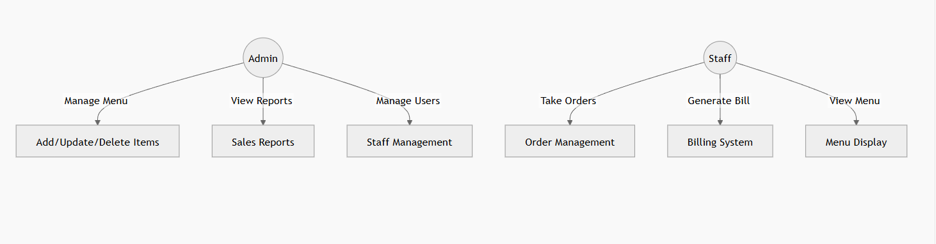
Fig 2: Use Case Diagram of Cafe Management System

2.4 System Progress (Mid Defense Status)
At the mid-defense stage, the following modules have been completed:
✅ Requirement Analysis
✅ System Design (Flowchart, Use Case)
✅ Database Design
✅ Basic UI Development
✅ Login System
Ongoing Work:
- Order Management Module
- Billing System
- Inventory Module

CHAPTER 3: SYSTEM DESIGN & IMPLEMENTATION

3.1 System Architecture
The system consists of:
- Frontend (User Interface)
- Backend (Server & Logic)
- Database

3.2 Modules of System
- Admin Module
- Staff Module
- Database System

3.3 Future Work (Final Defense Plan)
- Complete billing system
- Add inventory tracking
- Implement report generation
- Improve UI/UX
- Testing and debugging

REFERENCES
- IJCSIT (2023) – Restaurant Management System
- IJRASET (2022) – Café Billing System
- IEEE (2021) – POS Systems
- Online resources on café automation

